**Python Notes – Day 1**

**Topics: Introduction, Data Types, Expressions, Statements, Comments**

*Notes by – Learn Neural*

**1. Introduction to Python Programming**

**What is Python?**

Python is a **high-level**, **interpreted**, and **object-oriented** programming language with **dynamic semantics**. It supports multiple programming paradigms, including procedural, functional, and object-oriented programming. Python emphasizes **code readability** with its clean and easy-to-learn syntax, making it ideal for **beginners** and **professionals** alike.

🧑‍💻 Created by: **Guido van Rossum**  
📅 First Released: **1991**  
🧪 Current Version: [Check on python.org](https://www.python.org/)

**Key Features of Python:**

| **Feature** |  |  |  |  |  | **Description** |
| --- | --- | --- | --- | --- | --- | --- |
| **Simple Syntax** |  |  |  |  |  | Python code resembles English, making it easier to read and write. |
| **Interpreted** |  |  |  |  |  | Code is executed line-by-line; no compilation needed. |
| **Open Source** |  |  |  |  |  | Free to download, use, and modify. |
| **Cross-Platform** |  |  |  |  |  | Runs on Windows, macOS, Linux, and more. |
| **Extensive Libraries** |  |  |  |  |  | Huge standard library + third-party packages (NumPy, Pandas, etc.). |
| **Dynamic Typing** |  |  |  |  |  | No need to declare data types explicitly. |
| **Versatile** |  |  |  |  |  | Used in Web Dev, Data Science, AI, Automation, Games, etc. |

**Python Installation Guide**

**Step-by-Step Instructions:**

1. Visit the official website: [**https://www.python.org**](https://www.python.org/)
2. Navigate to **Downloads** → Select your OS (Windows/macOS/Linux)
3. Download the latest **stable release** (e.g., Python 3.12.X)

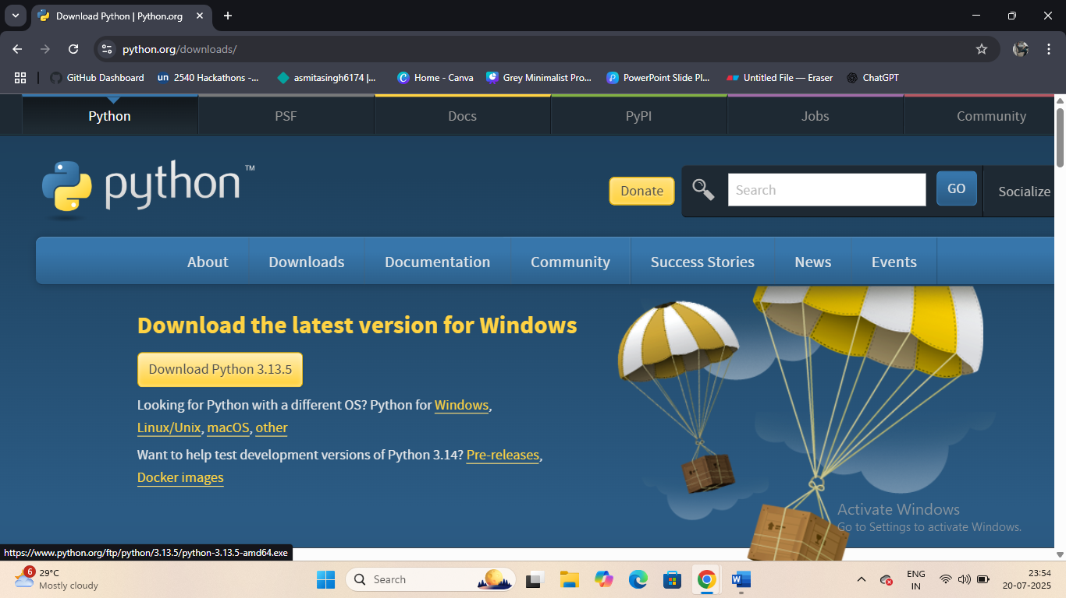

1. Run the installer:
   * Check **"Add Python to PATH"**
   * Click **"Install Now"**
2. After installation, open **Command Prompt (CMD)**:
3. python --version

Output should show something like:

Python 3.12.0

Also install **IDEs** like VS Code, PyCharm, or use online editors like Replit, Google Colab.

**2. Python Data Types**

Python automatically identifies the data type when you assign a value to a variable. This is known as **dynamic typing**.

**1. int (Integer)**

Represents whole numbers (positive, negative, or zero).

age = 21

**2. float (Floating-point number)**

Represents real numbers (with decimal points).

price = 99.99

**3. bool (Boolean)**

Stores either True or False – often used in conditions.

is_active = True

**4. str (String)**

Represents text or sequence of characters inside quotes (' ' or " ").

name = "Asmita"

**5. list (List)**

Stores an **ordered collection** of values (items can be of different types).

colors = ["red", "green", "blue"]

**Use type() to Check Data Type:**

print(type(price)) # Output: <class 'float'>

ℹ️ Python also supports more types like tuple, dict, set, complex, NoneType, etc.

**3. Variables, Expressions & Statements**

**Variables**

Variables are **named memory locations** used to store values. In Python:

* No need to declare the type
* Variable names must start with a letter or underscore _

x = 10

y = "Hello"

**Expressions**

An expression is a **combination of variables, operators, and values** that produces a result.

result = (x + 5) * 2 # 30

✔️ Returns a value  
✔️ Can be used inside other statements

**Statements**

A statement is a **complete line of instruction** to be executed by Python.

print("Welcome to Python!") # ← This is a statement

Types of Statements: (This will be thought in next class)*

* **Assignment** → x = 10
* **Conditional** → if, else, elif
* **Looping** → for, while
* **Function definition** → def greet():

**5. Comments in Python**

Comments are used to **document code** and **make it easier to understand**. They are ignored by the Python interpreter.

**Single-line Comment:**

Begins with #

# This is a single-line comment

**Multi-line Comment:**

Enclosed in triple quotes ''' or """

"""

This is a

multi-line comment

"""

**Best Practices:**

* Use comments to explain complex logic
* Avoid obvious comments like # print x above print(x)

**Quick Summary Table**

| **Concept** |  |  |  |  |  |  |  |  |  |  |  |  |  |  | **Example** |
| --- | --- | --- | --- | --- | --- | --- | --- | --- | --- | --- | --- | --- | --- | --- | --- |
| Variable |  |  |  |  |  |  |  |  |  |  |  |  |  |  | x = 10 |
| Expression |  |  |  |  |  |  |  |  |  |  |  |  |  |  | x + y |
| Statement |  |  |  |  |  |  |  |  |  |  |  |  |  |  | print("Hello") |
| Data Types |  |  |  |  |  |  |  |  |  |  |  |  |  |  | int, float, str, list |
| Boolean |  |  |  |  |  |  |  |  |  |  |  |  |  |  | is_active = True |
| Comment Syntax |  |  |  |  |  |  |  |  |  |  |  |  |  |  | # Single or """ Multi-line """ |

Keep Learning Developers…❤️